National University of Computer and Emerging Sciences, Lahore Campus

 | Course Name: | Human Computer Interaction | Course Code: | CS2007,
 | Degree Program: | BSSE | Semester: | Fall 2022
 | Exam Duration: | 150 Minutes | Total Marks: | 75
 | Paper Date: | 22-12-2022 | Weight | 45
 | Section: | ALL | Page(s): | 9
 | Exam Type: | FINAL EXAM
Student: Name: Roll No. Section:

Question#1 Identify the type of reasoning being used in the given scenarios. (5 marks)

I heard scratching sounds coming from the ceiling and noticed there were droppings on the floor. I’m pretty sure we have a mice infestation at our house | ABDUCTIVE
Jennifer always leaves for school at 7:00 a.m. Jennifer is always on time. Jennifer assumes, then, that if she leaves at 7:00 a.m. for school today, she will be on time. | INDUCTIVE
The scientists believe this drug will cure a genetic disease. They conduct experiments and collect data, which prove that the drug will cure the genetic disease. | DEDUCTIVE
Teachers from our school believed that a later start to the school day would help student learning. After a month of trying a new schedule, they determined that students learn better when school starts later. | DEDUCTIVE
The children in that house yell loudly when they play in their bedroom. I can hear children yelling in that house. Therefore, the children must be playing in their bedroom. | INDUCTIVE

Question# 2

- What are the physical properties of the Ponzo illusion? (Marks 2)

Consists of two lines of equal length, located between two apparently converging lines.
The top line is perceived to be longer.

- What is the difference between Productive and Reproductive problem? (Marks 3)

Reproductive problem solving draws on previous experiences whereas productive problem solving
involves insight and restructuring of the problem.
Question# 3 Draw an Action Cycle (following Norman (1988)) of Interaction Framework using these given below terms. There is no partial credit for this question. Need to use all the terms. (Marks 5)

Translate to action sequence
Interpret system state
Establish goal
Performance
Presentation
Formulate plan
Evaluate
Observation
Input
Output
Articulation
Computer

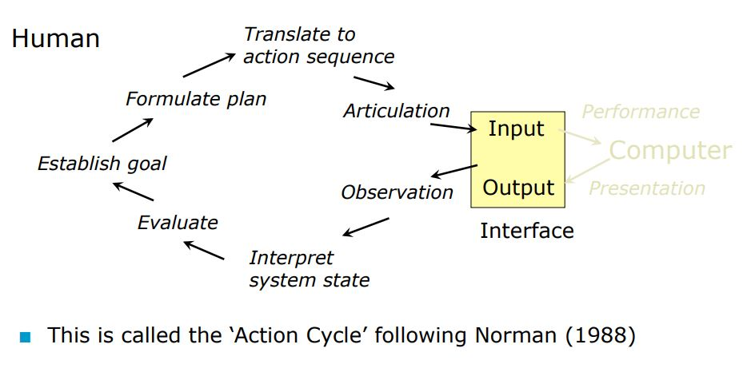

Question#4

- List down the FOUR tools for layout in the table given below (Marks: 2)

Tool Label | Tools for layout
T1 | G grouping of items
T2 | O ordering of items
T3 | Alignment
T4 | Decoration (color, font, etc.)
 | White space

- Write down six Common Interaction Styles in GUIs(Marks: 3)
Command line.
Question and answer.
Menus.
Form filing.
Function keys.
Natural Language
Graphical direct manipulation (pointing, clicking, dragging, typing).

- List down FIVE Benefits of user-friendly products to business users? (Marks: 5)

Increased productivity
Decreased user training time and cost
Decreased user errors
Increased accuracy of data input and data interpretation
Decreased need for ongoing technical support

- _ conceptual _ Modal design can be designed for very different technology platforms with different capabilities.

- ___ usability _____ Goal is to produce usable and safe system as well as functional system.

- The intensity of light emitted from a surface per unit area in a given direction is called ______ luminance__.

- The __ analogy _____ is used to solve a new problem by looking for similitudes with known situation and events for which the problem was solved.

- The ___ cognitive modal __ modal describes how people's thoughts and perceptions influence the way they feel and behave.

Question#5 (Marks 5)

Using the Fitt’s law, calculate the time it will take to acquire the triangle button (center of the button) shown in the figure below. Various measurements (in pixels) are given in the figure. Use the appropriate ones to calculate the time. Assume that the value of all coefficients (a and b) is 1. There is no partial credit for this question. Show all intermediate steps.

Hint:
Formula (MT = a + b*Log base 2 (2D/W)) a=1 and b=1
D=? W=?
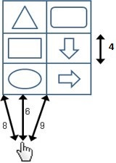

Working and Answer:

MT = a + b*Log base 2 (2D/W)
D = 16 (Till the center of target)
W = 4

1+1* Log base 2(8)
Answer: 4 seconds

Question#6 (Marks 10)

Hassan is a fresh freelancer, who has got a project to design the Mobile Application interface for a banking portal. Being an HCI student, guide Hassan on how to take up the designing project, stepwise. Make a 10 points plan, in order of execution. Your approach should encompass all important aspects of usability and designing.

- User description/identification
- Determine user characteristics
- Data collection, questionnaires
- Work environment analysis
- Usability requirements
- Interviews and observations
- Contextual Task analysis/ task scenarios
- Usability goals (quantitative/ qualitative goals)
- Conceptual Model
- Setting screen design standards/presentation rules
- Detailed UI design (tools for layout)
- Designing all primary and secondary screens (message boxes, dialog boxes, menus, error messages etc).
- Use of Norman’s and Ben’s principles
- Evaluation techniques

Question#7 (Marks 8)
The eight golden rules of Ben Shneiderman’s for interaction design are given below you need to write example for each rule.(Example not more than one sentence)
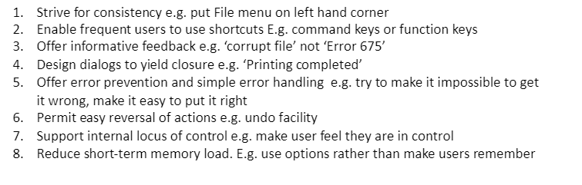

Question#8 (Marks 2+5)

Suppose you need to design an interface of ATM Machine for a handicapped person.
List 5 ATM operations and how each operation is implemented through interface for such user.

Question#9 (Marks 5)

Suppose you need to design an interface of vending machine in which there is no buttons or touch screen.
List 3 vending machine operations and how each operation is implemented through interface for such vending machine.

Question#10. Multiple Choice Questions: Write only ONE of the given options in the following questions.
(10 marks)
1 | A | 6 | B
2 | A | 7 | A
3 | B | 8 | B
4 | C | 9 | D
5 | D | 10 | A

- Providing accelerators increases (e.g. keyboard):
- efficiency
- learnability
- attitude
- utility

- Which of the following statement is true:
- Both preference and satisfaction goals are quantifiable
- Neither preference nor satisfaction goals are quantifiable
- Preference goals are quantifiable, but satisfaction goals are not
- Satisfaction goals are quantifiable, but preference goals are not

- What is a semantic network?
- A model of short-term memory
- A model of long-term memory
- A model of physical memory
- A model of short and long-term memory

What is a semantic network?
a) A model of short-term memory
b) A model of long-term memory
c) A model of physical memory
d) A model of short and long-term
4) The eye has ___________ for low light vision, __________ for color vision and __________ for pattern/movement.
- cones; rods; ganglion cells
- rods; ganglion cells; cones
- rods; cones; ganglion cells
- ganglion cells; cones; rods

- In virtual reality which of the senses cannot currently be portrayed?
- Touch
- Hearing
- Sight
- Smell

- Over a short period of time, we find it easier to remember the string of numbers “404 894 6743″ because:
- Numbers are easier to remember than arbitrary characters.
- The grouping of the numbers is significant
- Ten numbers are not that many to have to remember from working memory.
- None of these

- ___________ involves watching and listening to users.
- Observation
- Evaluation
- Qualitative research
- Interaction

- The small region of retina where optic nerve enters the eye is called:
- fovea
- blind spot
- ligament
- lens

- In human hearing process, the amplification of sounds is the responsibility of:

- inner ear
- middle ear
- medium ear
- outer ear

- There can only be one persona per interface for a product.
- Primary
- Secondary
- Supplemental
- Customer

